***Unilever Company***

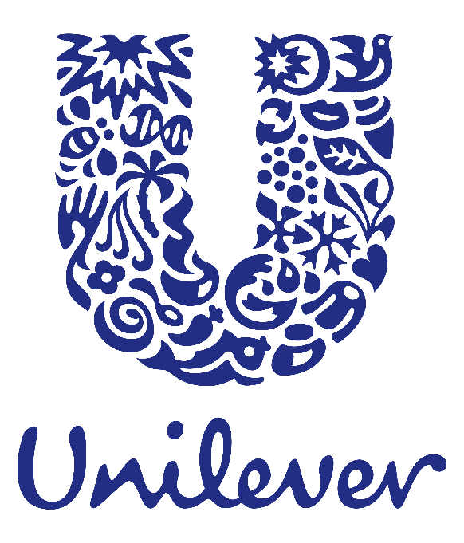

**Submitted by:**

Sheikh Sabit Islam

Roll: 01-039-14

Trainee

Computer Fundamental and Office Application

**Topic:** Comprehensive Project Using Microsoft Word, Excel, and PowerPoint

**Project**

**Course Title:** Computer Fundamental and Office Application

**Date of Submission:** December 04, 2024

**Submitted to:**

Dr. Md Manjur Ahmed

Course Instructor

Computer Fundamental and Office Application

**Contents**

1 Executive Summary: 1

1.1 Products: 1

1.1.1 Personal Care: 1

1.1.2 Home Care 1

1.1.3 Food and Nutrition: 2

1.1.4 Ice-Cream: 2

1.2 Services: 3

2 Business Plan: 4

3 Sales and Cost Statistics: 4

# 

# Executive Summary:

Unilever is a global consumer goods company offering a diverse range of products in personal care, home care, and food and refreshments. With iconic brands like Dove, Surf, Knorr, and Lipton, it serves millions of consumers in over 190 countries. Unilever emphasizes sustainability and innovation, aiming to create a positive social and environmental impact while delivering high-quality products. Its commitment to sustainable growth and consumer well-being has positioned it as a leader in the fast-moving consumer goods (FMCG) industry. Products and Services:

## Products:

### Personal Care:

Unilever's personal care segment is one of its largest and most impactful divisions, offering a wide range of products for skincare, haircare, oral care, and deodorants. Iconic brands like Dove, Sunsilk, Axe, Closeup, and Lifebuoy cater to diverse consumer needs globally. This segment focuses on combining innovation with sustainability, introducing products that promote personal well-being while reducing environmental impact. With a strong commitment to inclusivity and empowerment, Unilever's personal care brands often champion social causes, enhancing their connection with consumers worldwide.

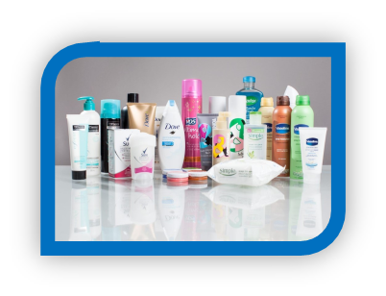

### Home Care

Unilever's home care segment focuses on providing high-quality cleaning and hygiene solutions for households worldwide. It includes well-known brands like Surf, Domestos, Comfort, and Cif, offering products for laundry, surface cleaning, and fabric care. The segment emphasizes innovation with eco-friendly formulations, such as biodegradable ingredients and reduced plastic packaging, to support sustainability. By addressing diverse consumer needs, Unilever's home care segment enhances cleanliness and convenience in everyday living.

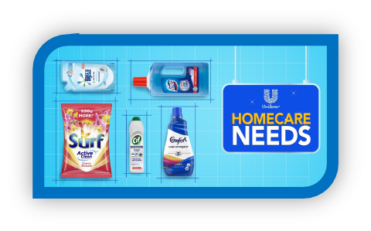

### Food and Nutrition:

Unilever’s food and nutrition division focuses on providing high-quality, sustainable, and nutritious products to consumers worldwide. Brands like Knorr, Hellmann’s, and The Vegetarian Butcher offer a variety of soups, sauces, condiments, and plant-based foods, promoting healthier and more sustainable eating habits. The company invests in innovative recipes to reduce salt, sugar, and fat while maintaining great taste. Through these efforts, Unilever contributes to addressing global food challenges and supports healthier lifestyles.

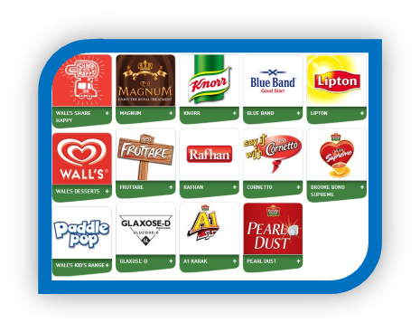

### Ice-Cream:

Unilever's home ice cream division is renowned for offering high-quality and diverse frozen treats under iconic brands like Magnum, Cornetto, and Ben & Jerry's. These products cater to various tastes and preferences, ranging from premium indulgence to fun, family-friendly options. Unilever focuses on sustainability by sourcing ingredients like cocoa and vanilla responsibly and reducing environmental impacts in production. Their innovative flavors and commitment to quality have made their ice cream brands favorites in households worldwide.

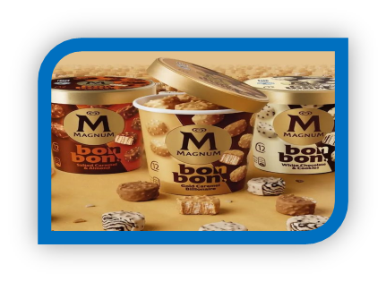

## Services:

* **Personal Care:**

Unilever offers skincare, haircare, and hygiene products through brands like Dove, Lifebuoy, and Tresemmé.

* **Home Care:** They provide cleaning and laundry products such as Surf, Comfort, and Domestos.
* **Food:** Unilever delivers food products and beverages through brands like Knorr, Hellmann's, and Lipton.
* **Ice-Cream:** They offer a wide range of ice cream products under popular brands like Magnum, Cornetto, and Ben & Jerry's.

# Business Plan:

**No**

**Find The Reason**

**Product Development**

**Leave From That Market**

**No**

**Yes**

**Sell to The Market**

**Start to Supply**

**Product Development**

**Market Analysis**

**Available Demand**

**Yes**

# Sales and Cost Statistics:

|  |  |  |  |
| --- | --- | --- | --- |
| **Product** | **Unit** | **Cost** | **Sales** |
| Home Care Product | 500 | 10 | 5000 |
| Personal Care Product | 800 | 20 | 16000 |
| Food Item | 1200 | 8 | 9600 |
| Ice-Cream | 2000 | 20 | 4000 |